Case Study:

A company would like to setup a messaging system that automatically broadcasts to all new

employees in a specific order.

The order of the messages is:

1. Welcome to Company XYZ!

2. Please remember to collect your laptop from the mobile clinic!

3. ANNOUNCEMENT: Stay safe and wash your hands.

Create a Kafka environment that simulates the following:

Kafka Broker = Messaging System

Consumers = Employees

All new employees to the company should receive the announcement messages in the specified

order above. Whenever there is a new message, employees should only receive messages that

they have never received before.

Optional Task (Bonus points): Create another group message that sends a different set of messages

to a specific department of people.

**Windows**

**Prerequisites**

* Installed Java Development Kit
* Installed and extracted Apache Kafka

**Zookeeper**

In Cmd to start up Zookeeper

bin\windows\zookeeper-server-start.bat config\zookeeper.properties

**Kafka Broker**

In Cmd to start up Kafka broker

bin\windows\kafka-server-start.bat config\server.properties

**Creating two Kafka Topics**

For new employees

bin\windows\kafka-topics.bat --create --topic employee --bootstrap-server localhost:9092 --partitions 1 --replication-factor 1

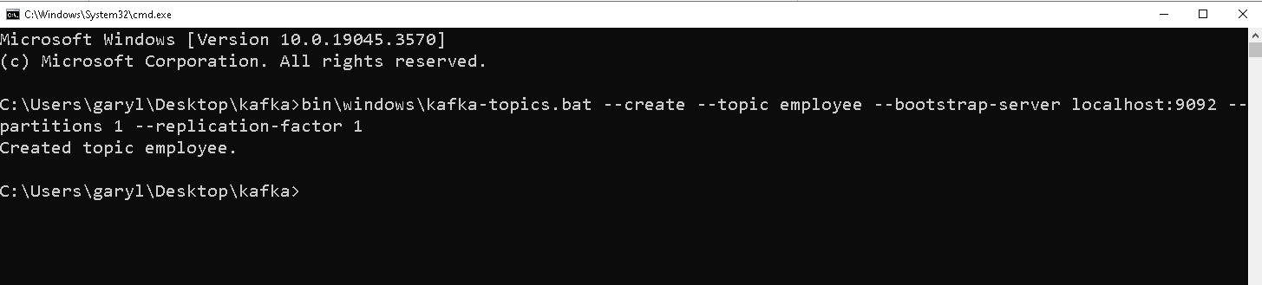

For HR department

bin\windows\kafka-topics.bat --create --topic hr --bootstrap-server localhost:9092 --partitions 1 --replication-factor 1

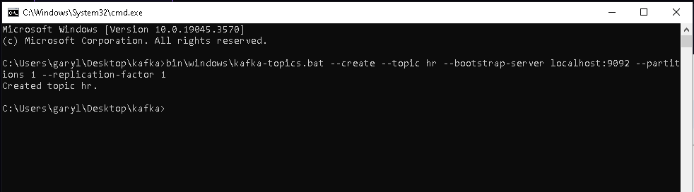

**Producing Messages**

employee_message

bin\windows\kafka-console-producer.bat --topic employee --broker-list localhost:9092

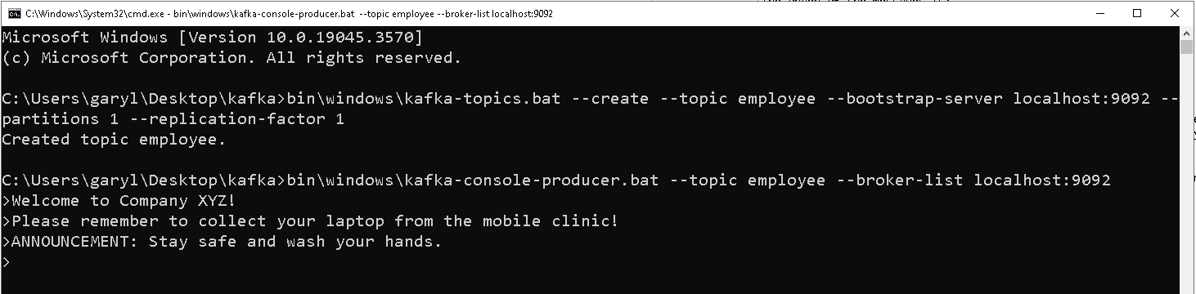

hr_message

bin\windows\kafka-console-producer.bat --topic hr --broker-list localhost:9092

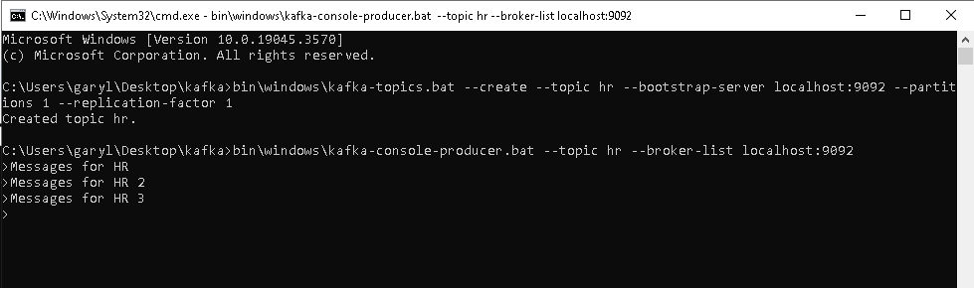

**Consuming Messages**

Using each cmd instance as a new user

Employee

bin\windows\kafka-console-consumer.bat --topic employee --bootstrap-server localhost:9092 --from-beginning

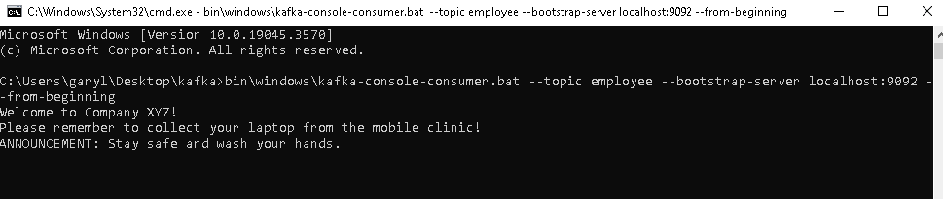

HR

bin\windows\kafka-console-consumer.bat --topic hr --bootstrap-server localhost:9092 --from-beginning

